<https://www.microsoft.com/en-us/learning/exam-az-900.aspx>

Contents

Cloud Concepts 1

Azure Services 10

# Cloud Concepts

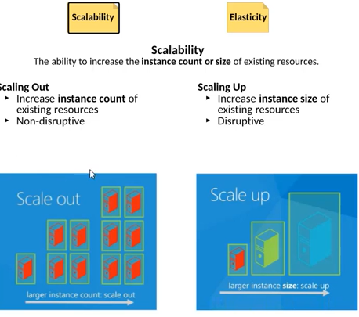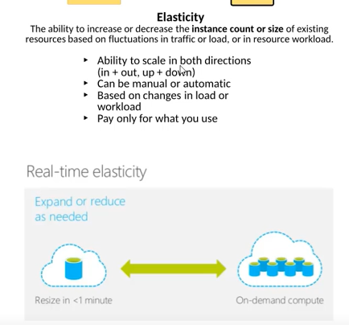

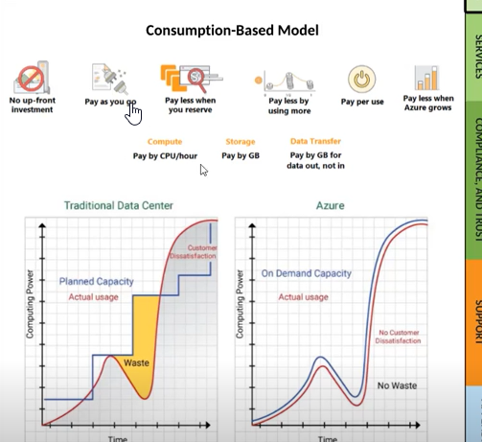

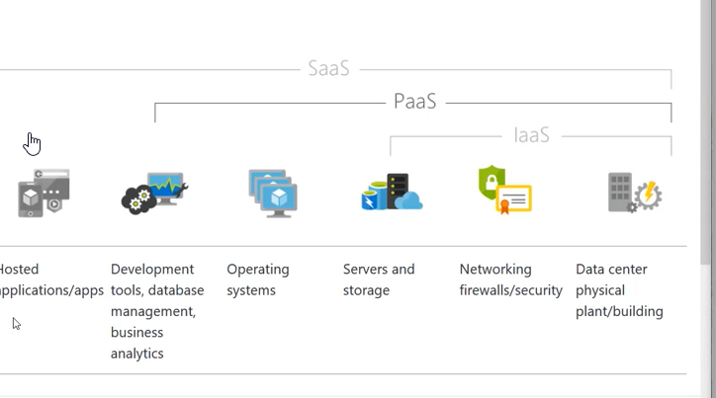

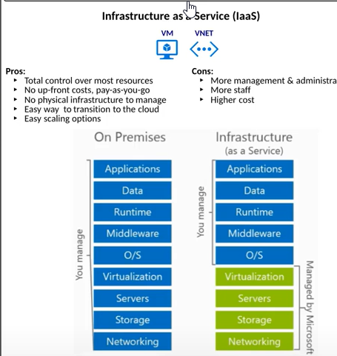  
Key word: “Consume”

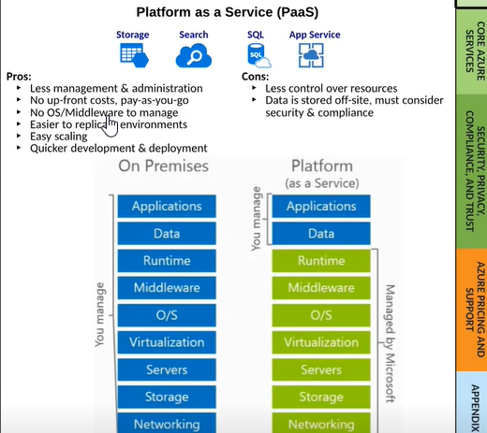

Middleware could be IIS / JVM that will be managed by Azure and not by the company paying for PAAS. Deploy your web sites using Azure App Services with no need to set up IIS etc.

Key word: “Build”

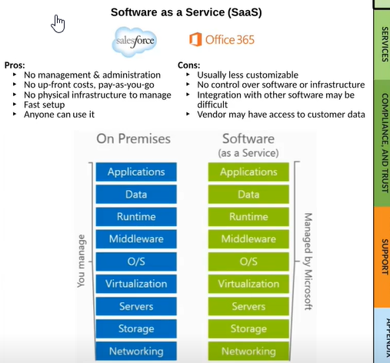

SaaS is the least used of the 3 – IaaS, PaaS and SaaS. Key word “Consume”

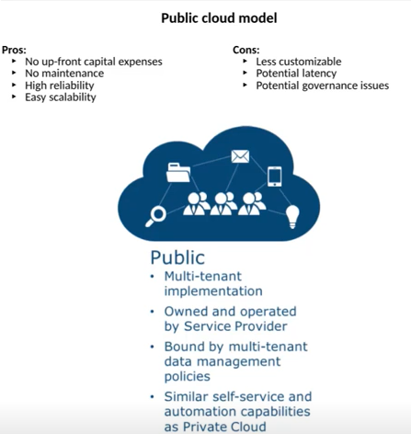

Multi-tenant – Multiple customers are sharing the same resources such as hardware, storage and servers etc. It is possible that the VMs of 2 companies could actually reside in the same server but one customer’s application issues do not bleed out / impact to other customers. There are protections built in to prevent such situations.

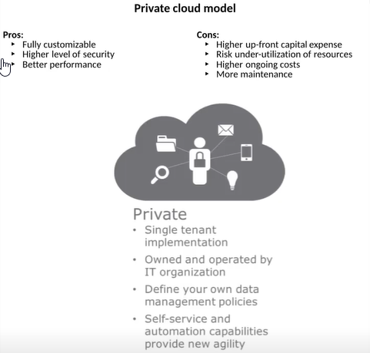

All the hardware is dedicated to a single customer. By defaukt, Azure can be a public cloud but many Azure products give you the ability to deploy them in a private cloud model. For example, VMs can be deployed in a private cloud model so that we can get a physical machine dedicated for ourselves.

Private Cloud can be the on-premises data center of an organization or it can be an isolated portion of someone else’s data center like Amazon / Azure.

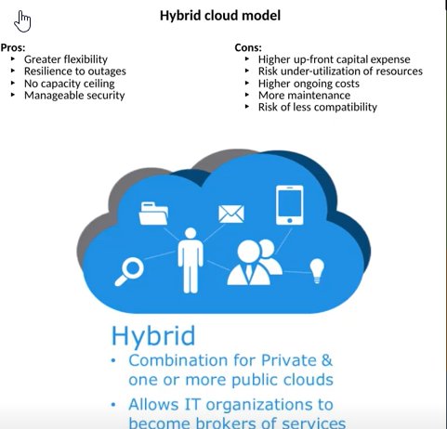

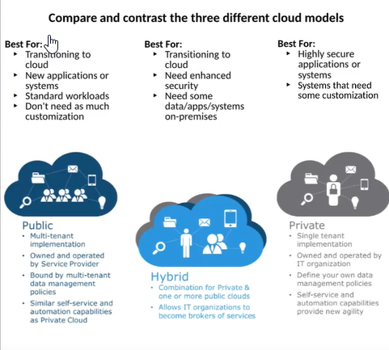

# Azure Services

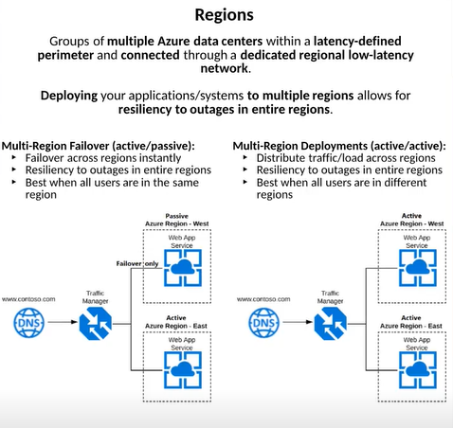

Active / passive set-up multi-region failover is expensive as the resources in passive region are not used most of the time.

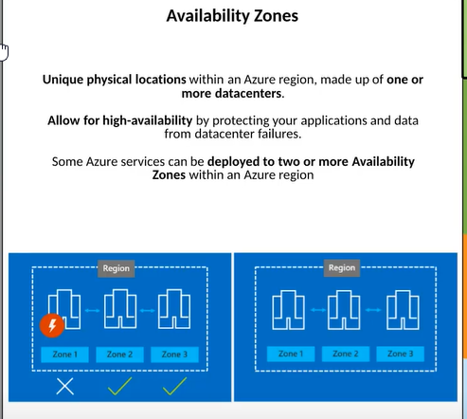

Some Azure services such as storage can be set up to replicate data across availability zones within one region or data can be replicated across multiple different regions.

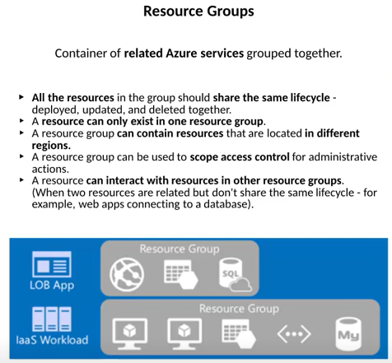

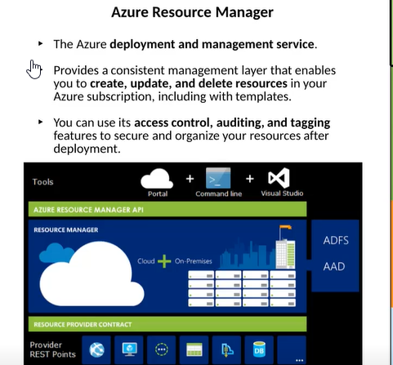

Azure Resource Manager (ARM)

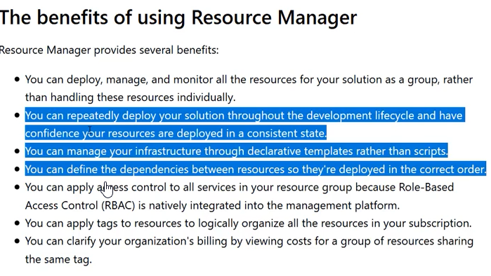

With the use of Azure Resource Manager (ARM) templates, you can repeatedly deploy our application and solutions. Create a template for a VM or app service or SQL DB and whenever we deploy the template, the same results will ensue. It avoids the manual work as you set up Dev, Test,Int, QA and prod environments.

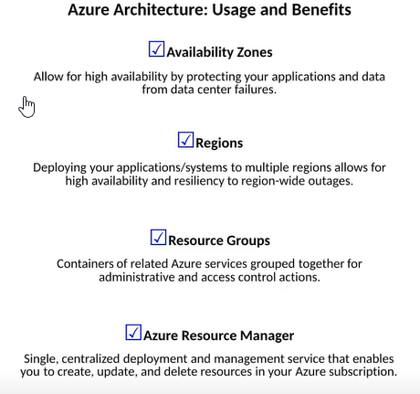

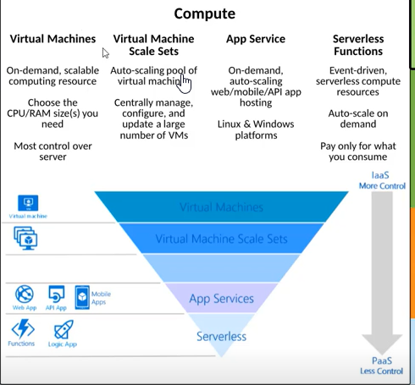

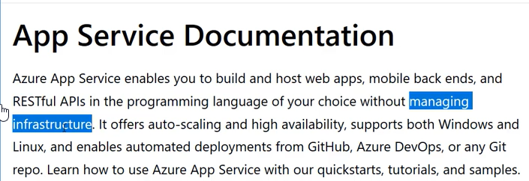

VMs and VM Scale sets are IAAS equivalents wherein we need to set up VMs and IIS / JVM etc.

App Services is PAAS equivalent wherein there is no need to provision VMs and IIS / JVM but it is charges a fixed cost monthly regardless of usage.

Serverless functions are the one where the service executes based on an event and is charged only for the duration it executes.

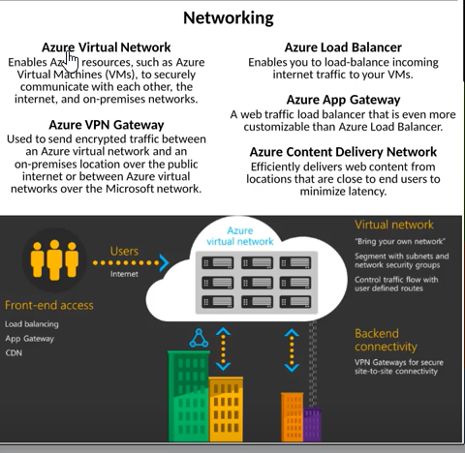

Azure App Gateway provides all functionality of Azure Load Balancer but provides more fine-grained customization over the Azure Load Balancer.

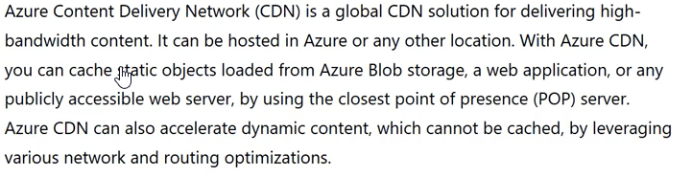

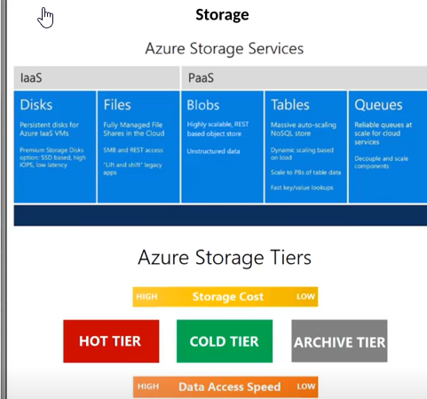

Storage tiers are for blobs.

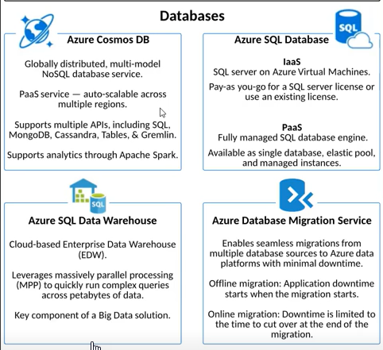

Cosmos DB is offered as a PaaS service and can be scaled across multiple regions so that the customer’s data is replicated across multiple regions and stays safe.

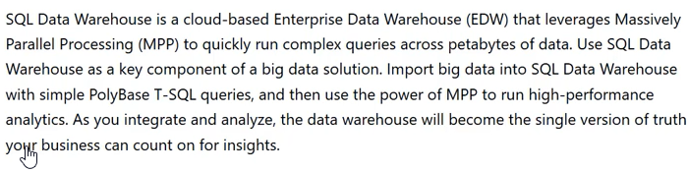

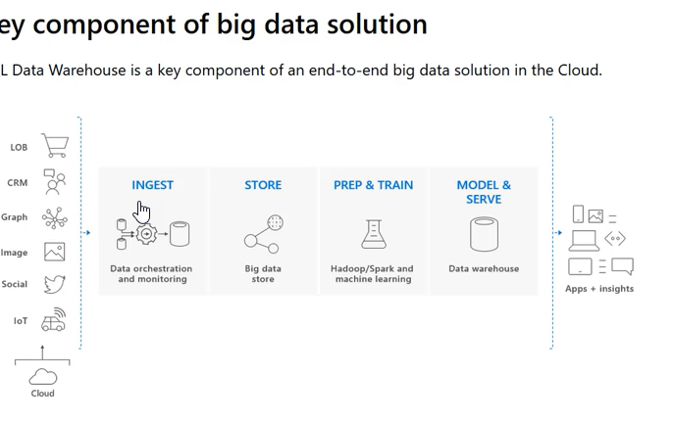

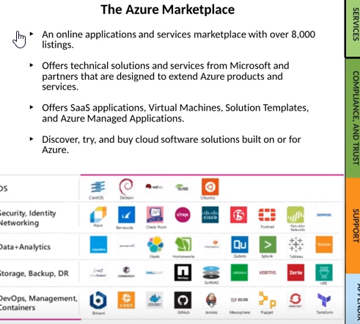

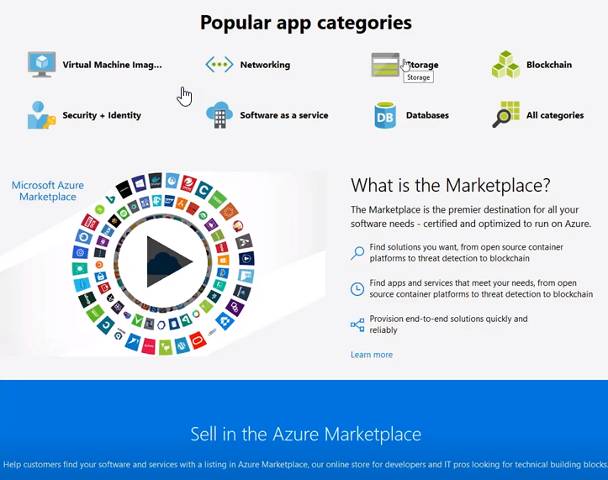

**Azure Solutions**

